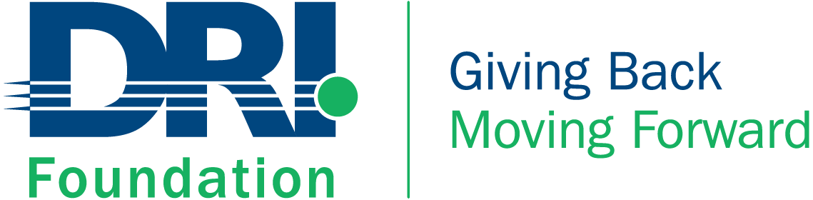  501(c)(3) charitable organization | Disaster Recovery International Foundation, Inc.  2 Park Place Suite #2B  Bronxville, NY 10708  scholarship@driif.org  (646) 619-3599  foundation.drii.org

The 2026 DRI Foundation Scholarship
University/College Undergrads Only

The DRI Foundation is keenly aware of the costs involved in higher education. We are also mindful that everyone must understand the need for preparedness; whether it is at the corporate, government or personal level. Preparing communities to respond to adverse events is everyone's responsibility. This is especially true for the next generations to come.

The amount of the scholarship will be $5,000 and payment will be made in the form of a check awarded to the scholarship recipient.

In order to be eligible for the scholarship, the applicant or the applicant's parent or legal guardian must be a DRI International Certified Professional in good standing and the applicant must be enrolled in a 4-year undergraduate program. The applicant must reside within the United States or Canada.

Applicants may only win the undergraduate scholarship once.

The Foundation is making every effort to ensure an impartial and objective awards process. Toward this end, all references to the applicant's actual identity will be removed and applications will be judged by an independent committee consisting of non-DRI staff, board members, commission/committee members and contractors. The committee that decides the winner of the scholarship is an all-volunteer committee and the members are not employees of DRI International or the DRI Foundation.

As part of the application process, there is a requirement to write an essay. The purpose of this is to have the student understand the aspects of preparedness by talking to professionals in Business Continuity, Disaster Recovery, Crisis Communications, Risk Management, Emergency Management and related fields.

Certainly, we expect the essay will be the work of the applicant. But as in the case of most essays, some research is required. The research may be in the form of a meaningful dialogue with a professional who works in the field.
Thank you,
Alan Berman
President & Chief Executive Officer
DRI Foundation
aberman@drii.org

The 2026 DRI Foundation Scholarship
University/College Undergrads Only

About the Scholarship
- The DRI Foundation Scholarship will be awarded to one University/College Student
- The amount of the scholarship will be $5,000 each
- Payment will be made in the form of a check awarded to the scholarship recipient
Application Instructions
- Please complete this application form to apply for the DRI Scholarship
- Applications must be submitted by midnight May 29, 2026, PDT
- Applications must be emailed to scholarship@driif.org
- Confirmations will be sent to applicants within 48 hours of receipt
- Incomplete applications will be judged as received, no supplementary information will be accepted
- Late applications will not be accepted
- All applications must be signed by entering full name
- PLEASE SUBMIT IN MSWORD (OR TEXT EQUIVALENT)
Requirements
- Applicant's Parent or Legal Guardian must be a DRI International Certified Professional in Good Standing
- Applicant must be enrolled in a 4-year undergraduate program for the upcoming fall semester
- Applicant must reside in the US or Canada
Process
- Applications will be received by DRI and assigned an identification number
- All applicants must sign the waiver at the end of this application by entering their full name
- All references to the applicant's actual identity will be removed to ensure impartial judgment
- Applications will be judged by an independent volunteer, non-compensated committee
- The decisions of the judges are final

Personal Information

First Name: Last Name:

Street Address:

City: State: Zip Code:

E-Mail:

Contact Phone Number:

DRI International Certification Name of Applicant’s Parent or Legal Guardian:

DRI International Certification Number of Applicant’s Parent or Legal Guardian:

Educational Information

4 Year College/University Attending:

Year of Study (freshman, sophomore, jr., sr.): GPA:

Major (if declared): Minor (if any):

Extracurricular School Activities and Recognized Achievements

Example: All-County, All–State, National, International Honors, Class President, etc.

Volunteer Activities

Be as descriptive as possible; include number of hours, duties and organization.

Essay Question

Preparedness, like any other effort requires commitment and resources. Given the necessity for making communities more resilient in the face of the many forms and degrees of risk. In response to this challenge, how would you approach preparedness/resilience planning in your community with limited funding and grant opportunities? Explain how you would elicit support for preparedness/resilience initiatives with policymakers and community leaders. Would you utilize Artificial Intelligence tools to bolster these efforts? If so, how?

Please provide your thoughts in 1,500 words or less (you may expand the space below to complete your essay).

Waiver

I certify that the statements herein are true to the best of my knowledge and grant permission for the information contained herein to be shared with the scholarship selection committee.

I understand my name and information from my academic history may be released to the scholarship selection committee. If awarded a scholarship, I release to DRI International and the DRI Foundation, the right to use my name, application information, story, and picture for printed and video materials, reports, and press releases, without compensation, as well as I will attend ceremonies and receptions.

I understand that the use of this scholarship is dictated by applicable country tax regulations. Failure to use funds for the purposes stated by said regulations will be grounds for forfeiture.

Applicant Signature (Please enter full name in lieu of signature):

Date:

Frequently Asked Questions

What is the DRI Foundation Scholarship and who is eligible? | The scholarship is awarded to a US or Canadian undergraduate who is enrolled in a 4-year college or university, whose parent or legal guardian is a Certified Professional in good standing at the time that the application is filed.
May an undergraduate win the scholarship more than once during their college or university enrollment? | No. An undergraduate may only win the undergraduate scholarship once. However, an individual who wins the HS senior scholarship will be eligible to win the undergraduate scholarship once.
For what can the scholarship be used? | Scholarship recipients must abide by local tax regulations. As prescribed by the IRS for the United States, the scholarship may be used to pay for tuition and fees required for enrollment or attendance at the educational institution, or for fees, books, supplies, and equipment required for courses at the educational institution.
How does one apply for the scholarship? | An application must be completed to apply for the scholarship. The application and instructions can be found on the DRI Foundation website, foundation.drii.org.
How will the winner of the scholarship be determined? | Completed applications will have all identification removed and will be reviewed by an independent committee. The committee will make its determination based on GPA, extracurricular activities, volunteerism activities, and an essay. The decision of the committee is final.
When does the application process begin? | Applications will be available on February 23, 2026. All applications must be submitted no later than midnight PDT May 29, 2026. The winner will be announced by June 26, 2026.

